USA Hockey 2009 Level 5 Symposium Thesis

The Evolution of Goaltending and
Proper Development Methods and Environment for Youth Goalies

Hiroki Wakabayashi
CEP # 308689
714-820-7797
hiroki@hockeylabjapan.com
Phoenix Jr. Coyotes Goaltending Coach
Highest Level: Nikko Kobe Ice Bucks (2005-06, Asia League Ice Hockey: Professional)
TABLE OF CONTENTS

Introduction 3
Summery of Corsi and Trottier’s speeches 4
The Evolution of Goaltending 4
Video Studies of Goaltending Now and Then 6
Analysis of Modern Goaltending 9
Human reaction time and goaltending 10
Advantages of Going Down movement 11
Applying the theory to Youth Goaltending Education 12
Sizing of the goal net for other youth sports 14
Introduction of Smaller Net for Youth Hockey 16
Conclusion: Proper Development Methods and Environment for Youth Goalies 17
References 20

Introduction
This thesis is inspired by the USA Hockey 2009 Level 5 Symposium speeches of Jim Corsi “Developing a Goalie – Connecting Technique + Tactics” and Bryan Trottier “Scoring in Today's game against Today’s Goalies”.
The first purpose of the thesis is to analyze the evolution of modern goaltending in conjunction with Corsi's and Trottier’s speeches then to provide some proof from scientific studies on human reaction time to support the predominant goaltending style in the NHL. The second purpose is to improve the teaching methods and environment to apply the predominant goaltending style for youth goalies.
Coaching youth level hockey after studying goaltending and coaching in professional level for over ten years, I have seen a great lack of understanding of modern goaltending theories in the youth hockey field. Most coaches rarely study modern goaltending and keep sending outdated teaching messages to the youth goalies such as “Come out from the crease and don’t go down for shots.” Moreover, I found that youth level goalies are not provided a proper environment to learn and develop the skills that they are supposed to employ when they get older and play in higher competitions.
The lack of updated knowledge of goaltending and proper environment to develop youth goalies might be occurring partly because there is not enough statistical / scientific evidence being presented to support the predominant goaltending style. This thesis will explain the recent predominant style from a statistical, scientific point of view, hoping to create a better environment and better methods for developing youth goalies.

Summery of Corsi and Trottier’s speeches
Corsi talked about the process of identifying technical elements of goaltending, breaking them down into drills and perfecting the skills in repetition then applying those skills into game situations (Tactics). He defines the technical elements as ‘Tracking the puck’, ‘Stopping the puck’ and ‘Puck Handling’. Tactical skills are defined as ‘Reads’, ‘Team Play’ and ‘Position’. Corsi then presented some basic skating skills drills and the applications of those skills in game footage as examples of connections of techniques and tactics.
Trottier on the other hand talked about how to score against today’s well trained goalies. Trottier sees today’s goalies are trained to cover the net well with good angle and butterfly skills. Goalies are also getting better at catching and blocking shots on top corners. To score on these goalies, shooters need to aim close to the goalie's neck and ears where it's harder for a goalie to reach. Shooters can also upset a goalie's timing and angle by hitch and fake shots. Trottier also suggests taking advantage of the “No Battle Zone” in order to have traffic in front of the net, as well as shooting to create rebounds for better scoring opportunities.

The Evolution of Goaltending
This section is to review the history of goaltending evolution in last 40 years.
“Jacques Plante on Goaltending (1972)” is considered to be one of the first comprehensive books about hockey goaltending. Plante and many of the goalies in his era played their game based on two theories, challenging out to the shot and staying on the feet for the save which has been referred to as “Standing-up style”. Standing-up style was developed in the era when the majority of shots were taken from outside of the slot with few lateral puck movements like passing, deking or rebound. After the famous 1972 Summit Series (Canada vs USSR), the standing-up style of making saves was no longer in style.
The European invasion changed the game of hockey in the 1980s. Offensive plays became lateral and in-close to the net instead of just straight down and shot from outside of the slot. The evolution of the lateral game forced the goalies to change their game and helped some goalie coaching experts like Warren Strelow and Francois Allaire to emerge. In the early '80s, Allaire started improving the mobility of goalies by using more technique of “push off, stop and face the puck” in order to move side to side rather than telescoping to the puck back and forth. These “push and stop” skating patterns and applications into the game are shown in Corsi’s video clips from his speech. To cover the net more efficiently, Allaire combined this simplified yet more efficient skating maneuver with the butterfly save technique, a technique employed by successful NHL goalies such as Glenn Hall and Tony Esposito since the 1970s. With the success of Allaire’s student Patrick Roy, this Quebec butterfly style became very popular in the NHL and led to its many successors today. “Roy and his butterfly style immediately became iconic for goalies throughout the province. Brodeur, who ironically opted not to use the butterfly, began idolizing Roy. Luongo did the same. So did Fleury, Jean-Sebastien Giguere, Jose Theodore, Martin Biron and many others.”
Although there are some minor differences in each goalie or each school of goalie coaching, goalies today are playing predominant butterfly style in very similar ways; as NHL commentator Resch states, “They’re all very similar. If not for the uniform, you couldn’t tell Hiller from Steve Mason in Columbus”. The evolution of goaltending style and equipment has improved goalie stats dramatically. It took Ron Hextall to record 3.00 GAA with an 89.4 Sv % to win the Vezina Trophy in 1986-87, but his stats can not even match the NHL average 20 years later (2006-07 NHL average : GAA 2.75, Sv% 90.6).
The next section is to statistically analyze this change of goaltending style by comparing NHL game videos from the 1980s and the 2000s.

Video Studies of Goaltending Now and Then
As Trottier sees from today’s NHL hockey, goalies nowadays are going down a lot to make saves after the successful evolution of goaltending. However, there are still arguments and critiques on “if and how often should a goalie go down to make saves”. NHL goaltending coach Mitch Korn states that “The “Butterfly” should be a “save” not a “style” and promotes goalies to have other saving techniques dependent upon each situation. “In reality, no goaltender is purely one style or another. They are a hybrid . . . a combination that depends on the way the goaltender plays different situations”. This hybrid concept sounds like an amalgam of stand-up style and butterfly but it seems very difficult to find any of the stand-up movements in most of the high-end hockey games today if the definition of the stand-up is staying on one's feet and making saves.
In order to reveal the reality of today’s goaltending, stats are taken from three NHL games from 1983, 2005 and 2009 to count the frequency of a “going down” movement for all shots on goals. The “going down” movement is defined by taking either skate off the ice to make the save such as a full butterfly save or a half butterfly save. On the contrary, the “staying up” movement is defined by staying up on both skates to make the save.
The first data are taken from May 17th, 1983, Edmonton Oilers vs NY Islanders playoff game. Edmonton goalie Andy Moog (height 5ft 6in) went down 74% (17 times out of 23 shots on goal) and stayed up 26% (6 times out of 23 shots on goal). NY Islanders goalie Billy Smith (5ft 10in) went down 52% (14 times out of 27 shots on goal) and stayed up 48% (13 times out of 27 shots on goal). The combined stats show 62% going down saves (31 times out of 50 shots on goal) and 38% staying up saves (19 times out of 50 shots on goal).
The second data are taken from May 1^{st,} 2006, Edmonton Oilers vs Detroit Redwings playoff game. Edmonton goalie Dwayne Roloson (6ft 1in) went down 95% (37 times out of 39 shots on goal) and stayed up 5% (2 times out of 39 shots on goal). Detroit goalie Manny Legace (5ft 9in) went down 90% (27 times out of 30 shots on goal) and stayed up 10% (3 times out of 30 shots on goal). The combined stats show 93% going down saves (64 times out of 69 shots on goal) and 7% staying up saves (5 times out of 69 shots on goal).
The third data are taken from May 20th, 2009, Calgary Flames vs Chicago Blackhawks playoff game. Calgary goalie Miikka Kiprusoff (6ft 2in) went down 100% (37 times out of 37 shots on goal) and stayed up 0% (0 times out of 37 shots on goal). Chicago goalie Nikolai Khabibulin (6ft 1in) went down 97% (36 times out of 37 shots on goal) and stayed up 3% (1 times out of 37 shots on goal). The combined stats show 99% going down saves (73 times out of 74 shots on goal) and 1% staying up saves (1 times out of 74 shots on goal). All the videos are edited and attached in .wmv format with this thesis.
Game | Going Down Saves | Staying Up Saves
1983 EDM vs NYI  (All_SOG3vintage.wmv) | Moog 74%(17/23)  Smith 52% (14/27)  Total 62% (31/50) | Moog 26% (6/23)  Smith 48% (13/27)  Total 38% (19/50)
2005 EDM vs DET  (All_SOG.wmv) | Roloson 95% (37/39)  Legace 90% (27/30)  Total 93% (64/69) | Roloson 5% (2/39)  Legace 10% (3/30)  Total 7% (5/69)
2009 CAL vs CHI  (All_SOG2.wmv) | Kiprusoff 100% (37/37)  Khabibulin 97% (36/37)  Total 99% (73/74) | Kiprusoff 0% (0/37)  Khabibulin 3% (1/37)  Total 1% (1/74)
Chart 1 : Saving Actions Against All Shots On Goal
Chart 1 clearly shows the dominance of “Going Down” movement in today’s goaltending in top level competitions. Despite the traditional argument regarding goalies who go down for the majority of the shots— Olympic Goalie Coach Joe Bertagna states: “Committing yourself before the shooter does is a cardinal sin for a goalie. The goalie is particularly vulnerable to high shots as well as shots through the legs”—the video stats show that current goalies go down over 90% of the time.
There are slight technical differences in every goalie but they all go down not only to stop low shots but to stop high shots, and their save percentage is higher than ever before.
The next section examines the reasons behind this predominant goaltending style.

Analysis of Modern Goaltending
The butterfly save was originally created to stop a low shot. The save is made by going down on the knees and spreading the leg pads outward flat on the ice. This movement is more effective than a skate save or a stick save because the width and length of the pads can take away a major part of the bottom of the net if the goalie’s angle and depth against the shot are correct. Statistically, about 80% of the shots are taken to the bottom two-thirds of the net (Chart 2), so the butterfly save is very effective to stop the majority of shots. The butterfly save works even better when the shot is taken closer to the crease because the scoring angle is decreased laterally and vertically. Thus the butterfly save technique has become very popular recently.
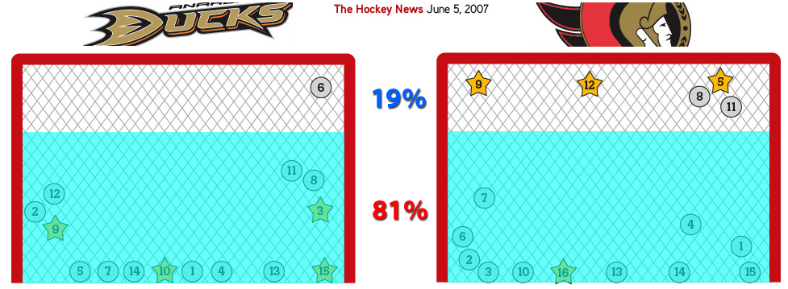
Chart 2 : All the Shots On Goal in ANA vs OTT 2007 NHL Playoffs

The growth of the average hockey player’s size has helped the improvement of butterfly style. In 1970 the average height of an NHL player was 5’11” and that has increased to 6’1” in 2006. However, the trend is effective even for undersized goalies as 5ft 9in Manny Legace goes down 90% of his game and had successful career in the NHL.
The improvement of the goalie equipment has also given goalies confidence to go down more often for shots. Recent goalie equipment is not only providing better protection of the body but is also creating a better blocking surface to make saves.
As stats show, this going down movement extends its usage to stopping middle and high shots in today’s game. Instead of staying up for high shots, goalies are committing to go down for almost every shot and yet find ways to react and reach out for high shots. The advantage of going down for high shots can be explained by scientific studies of human reaction time.

Human reaction time and goaltending
A goalie is challenged to recognize the direction and the speed of the shot and make the proper saving selection before the shot passes his/her body. According to a study on human reaction time (Donders, 1868), simple reaction time is shorter than recognition reaction time, and choice reaction time is longest of all. Laming (1968) concluded that simple reaction times averaged 220 msec but recognition reaction times averaged 384 msec. Choice reaction time increases by about 40 msec every time another item is added to the memory set (Sternberg, 1969).
Applying these studies to goaltending, selection of saving movement such as going down for low shots and moving the hands for high shots can be considered as the choice reaction. A goalie is given very limited time to choose proper saving movement in the game. When an 80mph shot is taken 25 feet from the crease, the puck reaches the goalie in 211 msec, which itself is already close to the human’s average simple reaction speed. During the real game situation, the shot can be taken from a closer distance so the goalie has to react in an even shorter time. Plus, the puck can move laterally and vertically before the shot is taken and there is traffic in front of the net most of time. These distraction increase reaction time as Welford (1980) and Broadbent (1971) reviewed.

Advantages of Going Down movement
In order to react to the shot and make the save in the very limited time that is given to a goalie, the “Going Down” movement is effective for the following reasons:
- A goalie can cover the most important part of the net
As discussed previously, 80% of the shots are taken and scored in the bottom two-thirds of the net. A goalie can cover a majority of the scoring area just by going down if he/she has the proper angle and depth to the shot.
Reaction time studies also show legs react 20% slower than hands, so committing to go down also gives a goalie quicker reaction tools = gloves to expect high shots and react to them.
- A goalie can narrow down the choices of reaction
Reaction studies say the more choices you have the longer reaction time you take. If a goalie has to make a choice between “Going down for a low shot” or “Staying up for a glove side high shot” or “Staying up for blocker side high shot”, he/she has three choices. If a goalie is committed to go down for most of the shots and expects to take high shots, the remaining choices would be only two: “glove side high shot” or “blocker side high shot”. This decision can save about 40msec of choice reaction time. Even if the shot is coming low, a goalie should make an easy save since he/she is already going down and covering a majority of the bottom part of the net. The shots aimed at the low corners can be saved by small adjustment of the butterfly position by stretching out the pad which is already on the ice. This commitment of going down and focusing on high shots can be called “Go Down and Play High Theory”.
This theory does not imply or encourage a goalie to go down before the shot is taken because these advantages of the theory only work when a goalie moves and gets in front of the puck before the shooter takes the shot and provides maximum net coverage first. Also, going down does not mean flopping on the ice onto the stomach or the back. A goalie must go down in stable butterfly or one-pad-down position so he/she can get up or slide over after the rebound.

Applying the theory to Youth Goaltending Education
Despite the dominance and success of the “going down movement” at the NHL level, there are still many critics and discussions against this theory in youth hockey. As Henrik Lundqvist, one of the top NHL goalies, remembered, “When I was 11 or 12, my coaches always told me that I went down to cover the bottom of the net too much and that there was no way it would work.” Former NHL goalie coach Steve McKichan also said, “Without question, the most common complaint coaches pass on to me regarding their youth goalies is the feeling that their goalies are going down too early. They go down too often.” The same type of question was asked from one of the audience in Corsi’s lecture in the symposium: “My little goalies are trying to copy NHL goalies' movement to go down on one pad on steep angle shots and give up top shelf. How can I tell them not to duplicate NHL movements?”
The reasonability of these arguments should be examined because no other sports teach youth players NOT to duplicate the movement of professional players which is employed in 90% of their game. Youth athletes are usually supposed to be encouraged to learn the fundamental skills from top players. If the skill is used in 90% of the professional games, it stands to reason it would be one of the fundamentals at any level of the game.
However, there is an obvious difficulty for applying this predominant goaltending theory to youth level hockey. The game of hockey has been using the same size net (6 feet wide and 4 feet tall) for all age groups from mini-mite to professionals. Having ten year olds, whose average height is approximately 4'3" play in adult size nets is not successful for proper development of skills.
If a youth goalie tried to go down for a low shot in the butterfly position, he/she still couldn’t cover low corners unless he/she comes out way too far from the crease. Coming out of the crease would make the goalie vulnerable to move across the crease to play lateral movement of the puck because his/her stride is shorter than adults. If the goalie stays inside the crease, he/she would give up too much space to shoot at. Going down for most of the shots like the professional goalies is extremely tough for youth goalies, simply because of the lack of vertical coverage with their height. (See Picture 1) All these disadvantages for youth goalies leave them playing very vulnerable in the net and learning very little fundamental skills to carry on to the next level.
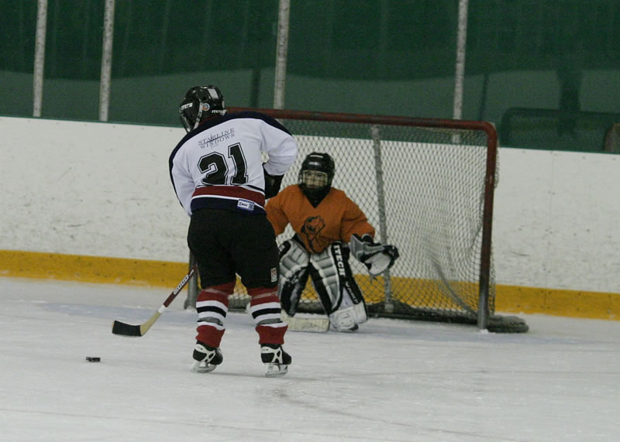
Picture 1 : Youth Hockey Goalie

Sizing of the goal net for other youth sports
In order to create a better developmental environment for youth hockey goalies, regulations of other youth sports should be studied and referred to.
In soccer, adult size goal nets (8-feet high by 24-feet wide) are used by players 12 years and older. U9 to U11 goal nets are regulated to 6 to 7 feet high by 18 to 21 feet wide. U7-U8 goal nets are 6 feet high by 12 to 18 feet wide. U6, for the youngest players, goal nets are the smallest at 4 feet high by 6 to 9 feet wide. Playing field sizes get smaller as well. (Picture 2)
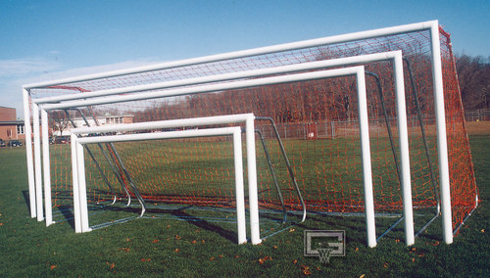
Picture 2 : Various Sizes of Soccer Goal Nets

Youth basketball has the same type of regulation for basket heights. 4-5 years olds use a 6 foot basket as do the 6-7 years olds. 8-10 years olds start using adult regulation which is 10 feet. Youth volleyball’s regulation for net height is set by age and categories as Men & Coed Mixed Sixes (7' 11-5/8"), Women, Boys 14-and-under & Reversed mixed Sixes (7' 4-1/8"), age 12 and under (7' 0"), and age 10 and under (6' 6"). The research shows other major ball games do consider the physical size deference between the youth and adult game and adjust the size of the goal net, the height of the basket/net, the weight of the ball and the dimension of the playing field according to the age group.

Introduction of Smaller Net for Youth Hockey
Although hockey has some difficulties on adjustment of the playing field’s dimension because of the nature of the ice rink facilities, at least it is rational to regulate two or three sizes of the goal net according to the age group. If the size of the net is set to 3 feet high and 4.5 feet wide for U11 and younger, the dimension for a goalie to cover will be decreased about 44%. This sounds like a very radical change but it gives a similar goalie/goal net ratio to the adult game as below. (Picture 3 and Picture 4)
Smaller nets allows youth goalies to move around the crease and get to optimal position to face the shot easily because they don’t have to come out too far to cover the angle or get in too deep to compensate mobility. It also benefits youth goalies to work on the going down movement to master the predominant goaltending style since they can actually reach for high shots with their hands while going down on their knees.
Smaller nets could decrease the number of goals in youth hockey because shooters won’t score as easily as “flipping the puck over the goalie’s shoulder”. However, it would force shooters to develop accuracy of the shot and to find better scoring skills and tactics to score on modern goalies as Trottier suggested.
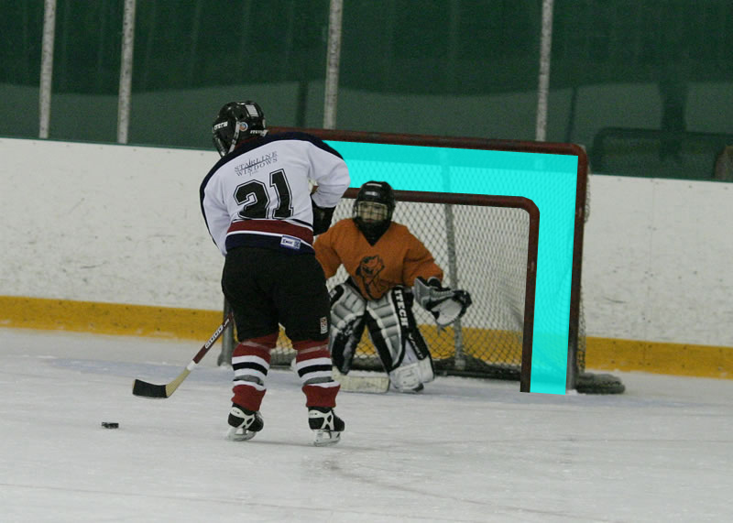
Picture 3 : Youth Size Goal Net Image 1

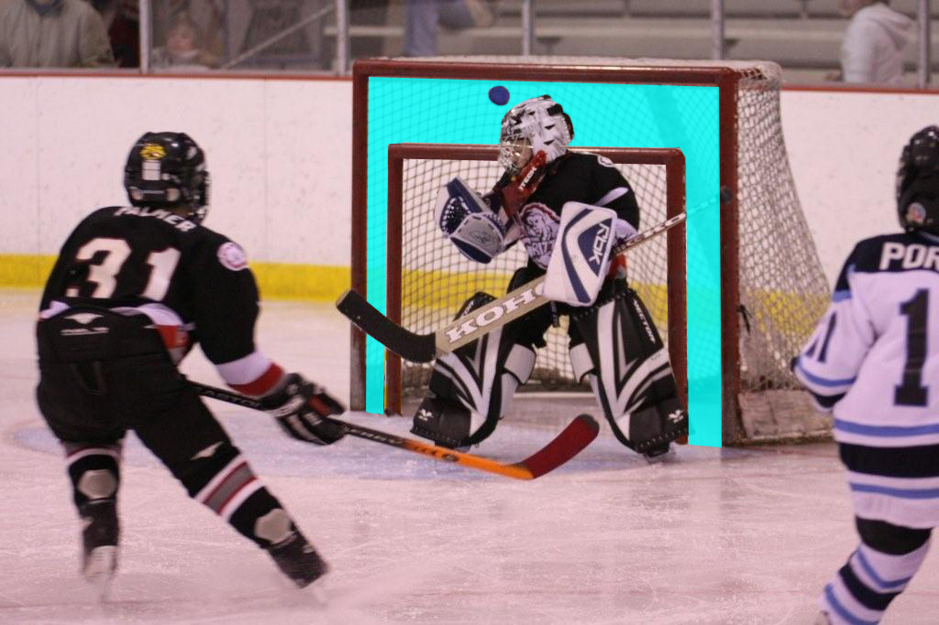
Picture 4 : Youth Size Goal Net Image 2

Conclusion: Proper Development Methods and Environment for Youth Goalies
Youth goalies should be coached by the methods that reflect modern goaltending knowledge and theories such as those introduced by Corsi and Trrotier in the symposium. Top level goaltenders today employ the going down movement for over 90% of their saving actions so it would be proper to say the going down movement is the predominant saving action in today’s goaltending. A goalie has the advantage when going down for almost every shot because he/she can cover most of the bottom part of the net where the majority of shots are taken and scored. Also, the going down movement allows a goalie to narrow the saving options to two, high on glove side or high on blocker side, which makes his/her reaction time shorter than having three options. Having only two choices of movement in the goalie’s game plan, his/her job now is basically to improve these hand movements to be quicker and more accurate on the high shots.
It is known that the choice reaction time can be improved from 30 to 40% by practice. Goalies can train their choice reaction in drills like those listed below.
- A goalie stands up at the top of goal crease and a shooter places pucks 25 feet away from the crease.
- The shooter takes five shots only to the goalie’s five-hole. The goalie is given only one option so he/she can work on quick and solid butterfly.
- Now the shooter can shoot the next five shots to the five-hole or glove side high. The goalie is given two options but going down on every shot narrows down the option to one, glove side high. He/she has to make sure to go down in a solid butterfly to take away the first option and then works on a quick glove reaction.
- Then the shooter can shoot the next five shots to the five-hole, glove side high or blocker side high. The goalie is given three options but going down on every shot narrows down the options to two, glove side high or blocker side high. He/she has to make sure to go down in a solid butterfly to take away the first option and works on a quick glove or blocker reaction.
- As the goalie improves the hand reactions, other options could be added like deflection beside or screen in front. All these drill should start from option one (five-hole) then increase the options one by one. (Picture 5)
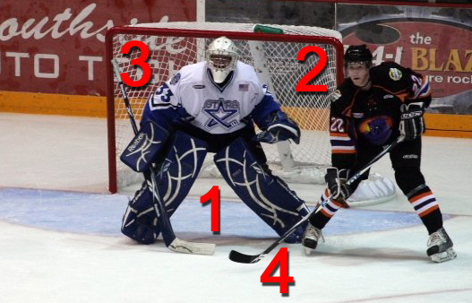
Picture 5 : Choice Reaction Drill

To train this “Go Down, Play High” theory, youth goalies should be provided a proper playing environment. The hockey world needs to research and follow other sports to create smaller sized nets for youth goalies. Smaller nets will give youth goalies similar net coverage as adults, thus they can develop better skating techniques to move to proper saving position and work on the predominant going down movement without sacrificing net coverage. Smaller nets would also help shooters to become more accurate and more creative, and to make goalies move laterally to create more scoring chances which would be beneficial for a better future of hockey.

References
Roy, M. 2008. Patrick Roy: Winning. Nothing Else. Wiley, Mississauga, ON

Rosen, Dan. 08.27.2009. Great minds, great goalies a hallmark of Quebec. 2010 Olympics. NHL.com

Allaire, François. 2009. The Hockey Goalie's Complete Guide: An Indispensable Development Plan. Firefly Books Inc., Buffalo, NY

KLEIN, J. Z. May 8, 2009. 2009 Playoff Goalies Are Almost Puck-Proof. New York Times NY edition

Korn, M. 2009. The Goalie Manual. Mitch Korn’s Specialized Hockey Camps, Oxford, OH

Welford, A. T. 1980. Choice reaction time: Basic concepts. In A. T. Welford (Ed.), Reaction Times. Academic Press, New York

Bertagna, J. 1976. Goaltending: A Complete Handbook for Goalies and Coaches. Cambridge, MA: Cosmos Press, Inc

Dunfee, A. and Janzen, M. June 5, 2007. Goal Breakdown: Where they scored from, where they went in. The Hockey News, Transcontinental Media G.P., Owen Sound, ON

Hockey Hall Of Fame Time Capsule : The 1970s. http://www.hhof.com/html/t700.shtml

Donders, F. C. 1868. On the speed of mental processes. Translated by W. G. Koster, 1969. Acta Psychologica 30

Laming, D. R. J. 1968. Information Theory of Choice-Reaction Times. Academic Press, London.

Sternberg, S. 1969. Memory scanning: Mental processes revealed by reaction time experiments. American Scientist 57

Welford, A. T. 1980. Choice reaction time: Basic concepts. In A. T. Welford (Ed.), Reaction Times. Academic Press, New York

Broadbent, D. E. 1971. Decision and Stress. Academic Press, London.

Rosen, Dan. 08.27.2009. Great minds, great goalies a hallmark of Quebec. 2010 Olympics. NHL.com

McKichan, Steve. 25/01/2008. Young goalies and teaching patience. Hockey Now Ontraio Edition.

US Youth Soccer Official Playing Rules

http://homeschooling.about.com/od/physicaledlinks/a/basketballrules.htm

http://wiki.answers.com/Q/How_high_is_a_volleyball_net

FSN Sport Science - Episode 3 - Reaction Time - Olaf Kolzig

Roy, M. 2008. Patrick Roy: Winning. Nothing Else. Wiley, Mississauga, ON, pp. 149.
Roy, M. 2008. Patrick Roy: Winning. Nothing Else. Wiley, Mississauga, ON, pp. 150.
Rosen, Dan. 08.27.2009. Great minds, great goalies a hallmark of Quebec. 2010 Olympics. NHL.com
KLEIN, J. Z. May 8, 2009. 2009 Playoff Goalies Are Almost Puck-Proof. New York Times NY edition, pp B13.
Korn, M. 2009. The Goalie Manual. Mitch Korn’s Specialized Hockey Camps, Oxford, OH, pp. 11.
Korn, M. 2009. The Goalie Manual. Mitch Korn’s Specialized Hockey Camps, Oxford, OH, pp. 56.
Bertagna, J. 1976. Goaltending: A Complete Handbook for Goalies and Coaches. Cambridge, MA: Cosmos Press, Inc, pp.20-21.
Dunfee, A. and Janzen, M. June 5, 2007. Goal Breakdown: Where they scored from, where they went in. The Hockey News, Transcontinental Media G.P., Owen Sound, ON, pp. 32.
Hockey Hall Of Fame Time Capsule : The 1970s. http://www.hhof.com/html/t700.shtml
Donders, F. C. 1868. On the speed of mental processes. Translated by W. G. Koster, 1969. Acta Psychologica 30: pp. 412-431.
Laming, D. R. J. 1968. Information Theory of Choice-Reaction Times. Academic Press, London.
Sternberg, S. 1969. Memory scanning: Mental processes revealed by reaction time experiments. American Scientist 57: pp. 421-457.
Welford, A. T. 1980. Choice reaction time: Basic concepts. In A. T. Welford (Ed.), Reaction Times. Academic Press, New York, pp. 73-128.
Broadbent, D. E. 1971. Decision and Stress. Academic Press, London.
Rosen, Dan. 08.27.2009. Great minds, great goalies a hallmark of Quebec. 2010 Olympics. NHL.com
McKichan, Steve. 25/01/2008. Young goalies and teaching patience. Hockey Now Ontraio Edition.
US Youth Soccer Official Playing Rules
http://homeschooling.about.com/od/physicaledlinks/a/basketballrules.htm
http://wiki.answers.com/Q/How_high_is_a_volleyball_net

